Please do the following to limit who can contact you. Meanwhile, I will post a reminder of the expectations of Moodle and its proper use.

1. Log into Moodle.
2. In the upper right corner, click on the Toggle Messaging Drawer. See image below.

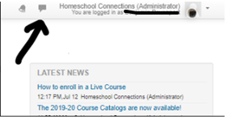

3. Click on the Settings icon. See image below.

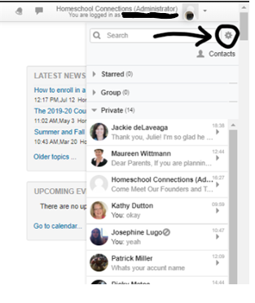

4. Change the folks who can contact Sam by restricting this list. Select My Contacts Only. See image below.

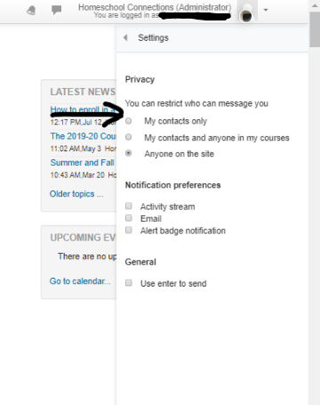

5. That is all there is to it.

